**Life Cycle and Log**

**TOTAL POINTS 10**

1.Question 1

In which method of an Activity do you usually call the setContentView method?

**1 / 1 point**



onCreate



onStart



onRestart



onResume



onPause



onStop



onDestroy

**Correct**

2.Question 2

Consider the life cycle of an activity:

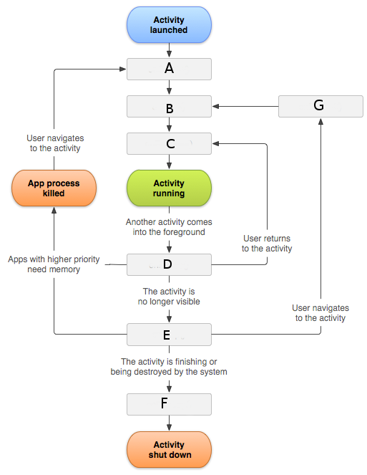

To which method does the 'D' refer?

**1 / 1 point**



onStart



onResume



onRestart



onPause



onCreate



onDestroy



onStop

**Correct**

3.Question 3

Which class from the Android API allows you to print debug messages to a dedicated view of Android Studio?

**1 / 1 point**

log

**Correct**

4.Question 4

The Log class allows you to print debug messages to a dedicated view of Android Studio. This class offers the following methods:

**1 / 1 point**



d(...), e(...), i(...) depending on the "status" of the message: debug, error, information.



print(...) and add(...)



d(...), e(...), i(...) depending whether you want to display a message ('d'), to raise an exception ('e') or to insert a message into the log ('i')

**Correct**

5.Question 5

The methods from the Log class usually call for 2 parameters:

**1 / 1 point**



The first parameter is the message to display, the second parameter is a tag which can be used to filter messages.



The first parameter indicates the status of the message (error, warning, debug, information), the second parameter is the message to display.



The first parameter is a tag which can be used to filter messages, the second parameter is the message to display.

**Correct**

6.Question 6

In which view/window of Android Studio can you examine the messages printed by the Log class?

**1 / 1 point**



debug



logcat



console



error log

**Correct**

7.Question 7

Which criteria can be used to filter messages printed by the Log class?

**1 / 1 point**



the tag of the message

**Correct**



the text of the message

**Correct**



the priority/level (debug, warning, error, information...)

**Correct**

8.Question 8

How can you send commands to the emulator?

**1 / 1 point**



I look for the id of the emulator in its upper right corner (usually 5554 for the first instance of the emulator) and I use the ADB tool to connect to it.



I use the AVD manager which was used to create and start the emulator, I select the emulator I want to control from the list of available emulators and I right-click on its line.



I look for the id of the emulator in its upper right corner (usually 5554 for the first instance of the emulator) and I use the telnet program to connect to it.

**Correct**

9.Question 9

Which command do you send to your emulator via telnet to simulate a fully charged battery? (hint: connect to your emulator and type "help")

**0 / 1 point**

power

**Incorrect**

10.Question 10

Which of the following commands are accepted by the emulator?

**1 / 1 point**



power display

**Correct**



sensor get

**Correct**



gsm call

**Correct**



sms send

**Correct**



shake on



finger touch

**Correct**



gsm accept

**Correct**



gps status